Assignment 2

Configuration for Jenkins

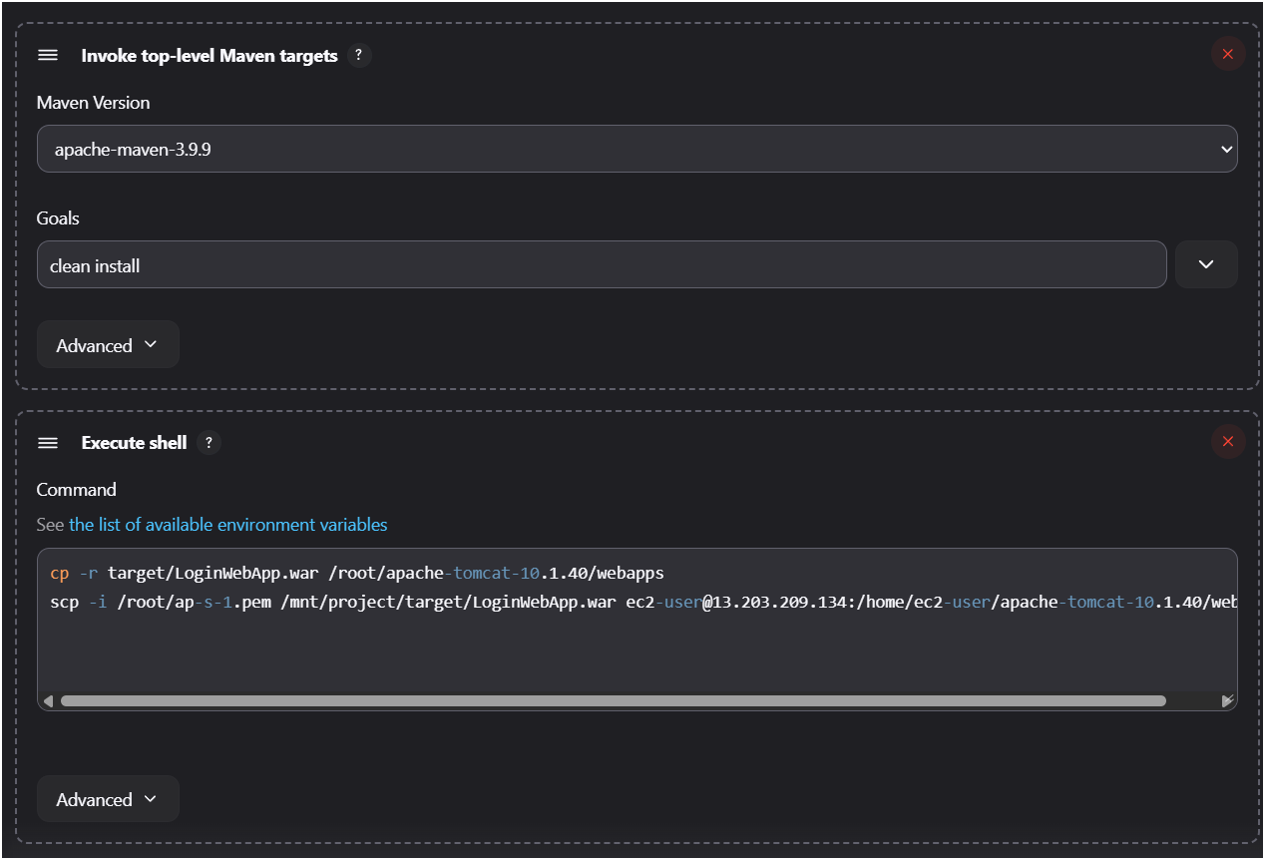

Consol output –

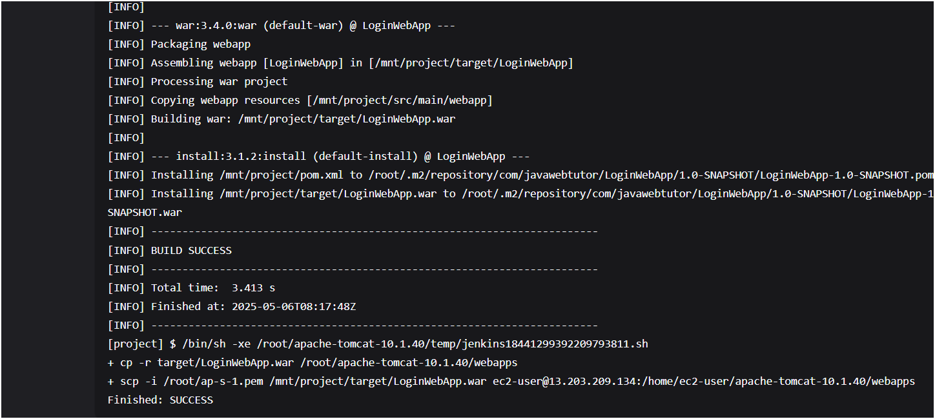

After that, need to manually restart tomcat for the changes to take effect..

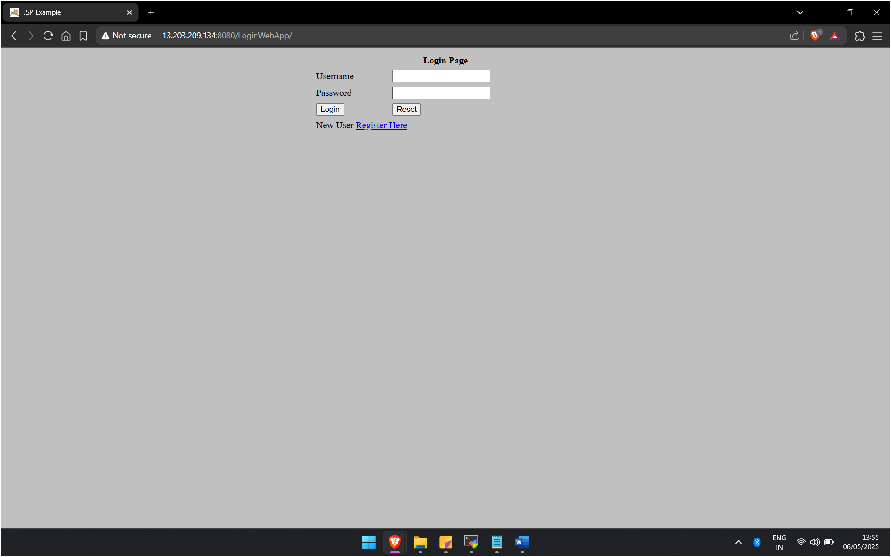

Login web app running on different machine where Jenkins is not installed